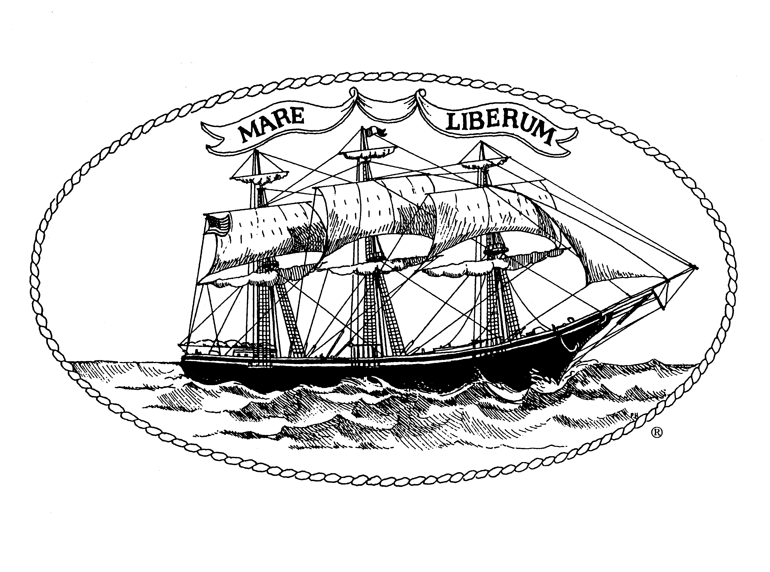

NOTICE OF FUNDING AVAILABILITY

Community Development Block Grant
Program Year 51 (July 1, 2025 – June 30, 2026)

Proposals Due:
Thursday, January 9, 2025 by 4:00 pm
E-Mail submissions will be accepted and is preferred or drop off at City Hall Community Development office, 2nd floor.
Applications submitted after the deadline will not be considered.
For an application, email or call Tom Bombria

Funding Managed by:
City of New London
Office of Development and Planning
Community Development Division
181 State Street
New London, CT 06320

Community Development Division Staff Contact Information:

Tom Bombria, Community Development Coordinator

E-mail: tbombria@newlondonct.gov (preferred)

Phone: (860) 437-6346

AN INFORMATION ZOOM MEETING SESSION WILL BE HELD ON 12/17/24 AT 10:00 A.M. OR CALL OR EMAIL QUESTIONS TO TOM
SEE PAGE 3 FOR DETAILS

The City of New London’s Office of Development and Planning (ODP) is the administering agency for the City of New London’s entitlement grant under the Community Development Block Grant (CDBG) Program, a Federally funded program of the U.S. Department of Housing and Urban Development (HUD). The amount of CDBG funding that will be available for Program Year 51 (7/1/25-6/30/26) has not yet been provided by the U.S. Department of Housing and Urban Development. However, last fiscal year the City of New London received $815,436.

CDBG funds may be used for a wide range of activities with specific activity funding decisions made at the local level. All program activities must:
- Benefit low- and moderate-income persons as defined by HUD; or
- Provide physical improvements to an area characterized by slum or blight.

The Office of Development and Planning will accept applications in the following categories:

- Public Services – Public Services include social/health services provided to low- and moderate-income New London residents. All funds awarded must be spent within this program year. The City will not accept requests for food as part of a program’s scope of services except for nutritional programs including food banks and shelters. 51% of clients served must be below income limits set by HUD each year.

- Public Facilities & Improvements – such activities include improvements to youth centers, homeless shelters, streets and streetscapes, etcetera. If your agency is applying for funds under this category, please read the application carefully; important information has been added to ensure cost estimates are accurate. All construction project funds must be expended within three (3) years of award. After three years, any remaining funding will be reallocated to another project.

- Rehabilitation & Preservation – such activities include residential and non-residential/commercial/historic building improvements. There are many restrictions in this category, so please contact the Community Development Coordinator prior to submitting an application under this category. All construction project funds must be expended within three (3) years of award. After three years, any remaining funding will be reallocated to another project.
The public facilities application can be used for #2 & #3.

Organizations that receive funding will be required to enter into a contractual agreement with the City of New London for the provision of services/activities stated in the application. All organizations that receive funding will be required to comply with all data collection, reporting and monitoring requirements as established by HUD and the City of New London.

General Instructions for Application Submission

The following instructions describe the information required from all applicants who are requesting funds. Please submit all applicable information requested. Failure to do so may jeopardize your chances of receiving funding.

REQUIRED OF EVERY APPLICANT:

- Provide one (1) copy of the proposal with an original signature on the front page.

- Limit your Part II narrative responses to four pages.

- Submit only one (1) copy of the supplemental information.

- Use a font size that is 10 points or larger and leave a minimum of 1-inch margins on all sides.

- Do not bind your application

- Do not add a cover letter, title page, dividers, tabs, etc. The front page must be the cover page of the application (Part I: General Information)

- Do not submit oversized attachments (nothing larger than 8½” x 11”)

- Do not include information not requested in the application

- Do not submit the application via fax. Applications submitted in this manner will automatically be rejected.

Application Information Session/How to Get an Application Packet
To assist prospective applicants in the application process, an information session will be held on Thursday, December 17, 2024, at 10:00 a.m. as a ZOOM meeting, in which interested applicants can participate via zoom video or by calling in only.

https://us06web.zoom.us/j/88952770198?pwd=AXqZ3sKzmdzac8noKHZISaAYlbjlWt.1
Meeting ID: 889 5277 0198 Passcode: 823072 Phone: 1 646 558 8656

This session should last no more than one hour. A short presentation will be made and then the meeting will be open to specific questions by the applicants. Please submit any questions by email before the session, if possible. The meeting access details will be announced on the City’s website under “CDBG Info Session.”

You can arrange to have the application electronically mailed to you by contacting one of the Community Development Division staff (contact information is located on the cover page of this Notice of Funding Availability). The application packet will also be available in hard copy at the City of New London, Office of Development and Planning, 181 State Street, New London, CT 06320 through January 9, 2024. Please review the current year application for any changes that may have been made to the prior year format.

There will be two public hearings held before the City Council to assist them in making their funding recommendations/decisions. It is highly recommended that a representative from your agency make a brief presentation at the first hearing of City Council scheduled for February 17, 2025 at 5:30 p.m.

Schedule
A schedule of important dates associated with the CDBG application process will be included as part of the application package.

*****

If you have any questions regarding any part of this process or require technical assistance, please contact Tom Bombria, Community Development Coordinator via e-mail (preferred) at tbombria@newlondonct.gov (860) 437-6346.

ELIGIBLE ACTIVITIES

* Public Service Activities

- Social services provided to residents in need

- Programs must serve at least 51% New London residents,
who are extremely low, very low or low-moderate income
(see chart)

AREA MEDIAN INCOME

FAMILY SIZE | EXTREMELY LOW INCOME (30%) | VERY LOW INCOME (50%) | LOW-MODERATE INCOME (80%)
1 | $ 24,000 | $ 40,000 | $ 63,950
2 | $ 27,400 | $ 45,700 | $ 73,100
3 | $ 30,850 | $ 51,400 | $ 82,250
4 | $ 34,250 | $ 57,100 | $ 91,350
5 | $ 37,000 | $ 61,700 | $ 98,700
6 | $ 41,960 | $ 66,250 | $ 106,000
7 | $ 47,340 | $ 70,850 | $ 113,300
8 | $ 52,720 | $ 75,400 | $ 120,600

