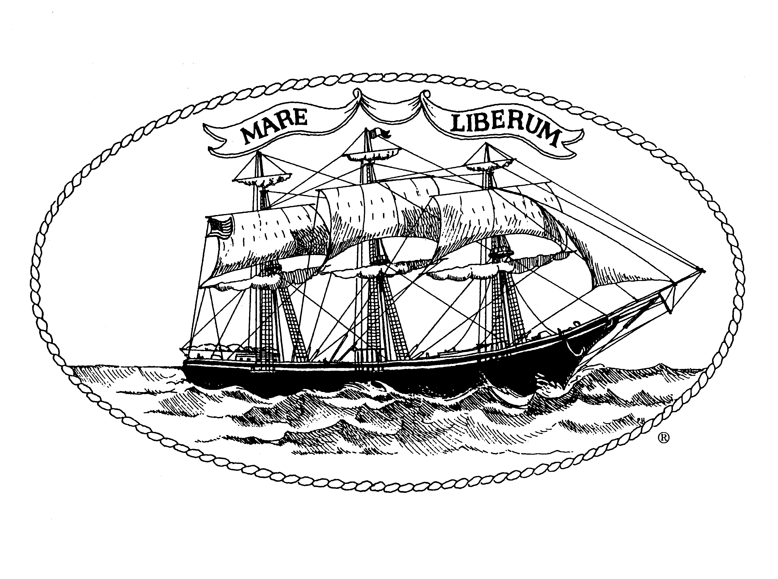
City of New London

Community Development Block Grant Program
Fifty First Program Year
July 1, 2025 – June 30, 2026

Public Facilities Improvements Application
Due Date: January 9, 2025 by 4:00 pm

Note: Also Review “Notice of Funding Availability”

Part I: General Information

Agency/Department:

Address:

Exec. Dir./Dept. Head:

Project Director/
Contact Name & Title:

E-mail Address of Contact
Person (Required) ________________________________________________________________

Telephone:

Proposed Project Name:

Person Authorized to Sign
On Behalf of Agency:

Person Authorized to
Request Funds:

CDBG Request & Award Amounts: Request Award

Upcoming Fiscal Year
(July 1, 2025 - June 30, 2026) $ $

If Current Fiscal Year Award
(July 1, 2024 - June 30, 2025) $ $

I/we certify that the information contained herein and attached as exhibits hereto is, to the best of our knowledge and belief, true, correct and complete and that the City of New London can rely upon these statements in determining whether to fund this project. We certify that the Agency Board of Directors has approved this application.
□ The NOFA contains guidelines for applicants with updates each year. Please verify you have read the NOFA.

Exec. Dir./Dept. Head Date Chair, Board of Directors Date
Part II: Project/Agency Information

- Proposed Project Description

    - Provide a general description of the proposed project.

- Clearly state exactly what the requested CDBG funds are to be used for.

- Describe the activities to be performed or services to be provided.

- Do you anticipate any temporary or permanent relocation of persons or businesses because of
this project? Is so, please explain.

    - Need for the project.

  - Explain the need/problem to be addressed.

  - Explain how this project will address the needs of the community.

    - Identify the target population or the area that will benefit from this project.

    - Provide an implementation schedule/timeline for the completion of this project. If awarded funding, your agency will have to go out to bid to ensure an open, fair competition for Federal funds. Please allow approximately two months to competitively procure the services of contractors. Community Development Division staff will guide subrecipients in the procurement process.

    - Quote for work to be done.
All applications must provide at least one estimate for the construction work that is proposed. Any construction work over $2000 requires that Davis Bacon Act labor standards are followed. Prevailing (union) wages shall be paid to all workers (non-owners) for the entire project, whether completely funded by CDBG or not. The quote provided with your application must take into account prevailing wages and must be noted on the quote. If the contractor you are getting the quote from is not familiar with this requirement, please visit. https://sam.gov/wage-determination/CT20230024/8 Once on this page, scroll to New London County, Town of New London and then select the appropriate classification. The wages for various categories of workers will be displayed. If the contractor does not provide his/her employees with fringe benefits, the rate of pay must equal or exceed the rate plus the fringes noted in the wage decision. These wages change periodically and the most recent wage decision will be used when the project goes out to bid. Davis Bacon Act rules require specific language in all contracts. Please look up Davis Bacon Act requirements or visit www.sam.gov for help. Contact Community Development staff after award and before any request for proposals are solicited if needed.

    - Reduced funding questions.

  - If you do not receive the amount of funds requested, how do you propose to administer and/or complete the project?

  - What items would you reduce or eliminate from your budget?

B. Addressing a CDBG National Objective:

Does your program:

Address the needs of low- and/or moderate-income residents?

OR

Eliminate Slums or Blight?

C. Agency/City Department Information (City departments: write this section as if you are submitting the application to an entity that does not know how your department/program operates. This is necessary to meet the requirements of the program.)

      - Background/Program Experience: Include the length of time the agency has been in operation, the date of incorporation, the purpose of the agency, and the type of corporation. Describe the type of services provided, the agency’s capabilities, the number and characteristics of clients served, and license to operate (if appropriate).

      - Personnel/Staff Capacity: Briefly describe the agency’s existing staff positions and qualifications, its capacity to carry out this activity, and state whether the agency has a personnel policy manual with an affirmative action plan and grievance procedure.

      - Monitoring: Briefly describe how you will monitor progress in implementing the project. Attach copies of data collection tools that will be used to verify achievement of project goals and objectives. Describe who will be responsible for monitoring progress.

Part III: Financial Information
- Financial Capacity: Describe the agency’s/department’s fiscal management including financial reporting, recordkeeping, accounting systems, and payment procedures. City Departments are required to respond to this section.

- Sources of Revenue: Please complete the budget table below demonstrating your total agency/department estimated revenue by source and the project’s sources of funding. City Departments are required to respond to this section.

Revenue Source for Your Agency/City Department | Estimated Total Agency Budget | Proposed Project Budget
Program Fees
United Way
Foundations
Donations

CDBG (requested amount)
NL General Fund
State Government
Federal Government
Other Revenue (specify in lines below)
TOTAL REVENUE

- TOTAL PROPOSED PROJECT BUDGET IS WHAT PERCENTAGE OF THE
TOTAL AGENCY BUDGET? %

- CDBG AMOUNT REQUESTED IS WHAT PERCENTAGE OF THE TOTAL
PROJECT BUDGET? %

3. CDBG AMOUNT REQUESTED IS WHAT PERCENTAGE OF TOTAL AGENCY BUDGET? %

C. Proposed Project Detailed Budget: Please complete the budget form below breaking down the proposed project costs by category. Please estimate these figures based on the quote(s) received and included in this application. Important: Include breakdown on how other sources of funds are going to enable you to complete the proposed project. Please note that the City of New London is not expecting your agency to get a quote from a contractor that is more detailed than what is normally provided. The quote(s) submitted with this application must state clearly that the estimate is based on current prevailing wages for construction workers.

 | Source of Funds:  CDBG | Other  Source of Funds:  * Please fill this box in | Other  Source of Funds:  * Please fill this box in
Salaries/wages:
Payroll (List each person’s payroll involved with the project.)
Overtime
Salaries Subtotal
Fringe Benefits ( % of wages)
Purchased Services:
Engineering/Architect
Consulting
Legal Services
Professional Services
Advertising
Printing
Dues & Subscriptions
Travel & Transportation
Rentals & Leases
Training
Other Operating Services
Postage
Courier
Telephone
Maintenance & Repairs Services
Purchased Services Subtotal
Supplies & Materials:
Consumables
Computer Equipment
Supplies Subtotal
Capital Improvements:
Capital Improvements other than Buildings
Capital Subtotal
Grand Total:

Part IV: Supplemental Information
Exhibits Not Required for Applications Submitted by
City of New London Departments
All agencies must submit the following documentation with their application whether or not you have previously received CDBG funds through the City of New London.

Please provide only one copy of these materials.

Exhibit 1 Financial Statement/Audit
Include a copy of your organization’s most recent audit report or a financial statement. If your organization is not required to complete an audit report based on the amount of Federal funding expended during the previous year, please submit a detailed financial statement.

Non-Federal entities that expend $500,000 or more in a year in Federal awards shall have a single or program-specific audit conducted for that year in accordance with the provisions of OMB Circular A-133 – Audits of Institutions of Higher Education and Non-Profit Institutions.

Exhibit 2 Insurance/Bond/Worker’s Compensation
- State whether or not the agency has liability insurance coverage, in what amount and with what insuring agency.
- State whether or not the agency pays all payroll taxes and worker’s compensation as required by Federal and State Law.
- State whether or not the agency has fidelity bond coverage for principal staff who handle the agency’s accounts, in what amount and with what insuring agency.
- Provide a copy of a current insurance certificate, not a policy.

Exhibit 3 Non-Profit Determination
Non-profit organizations must submit tax-exemption determination letters from the Federal Internal Revenue Service.

Exhibit 4 List of Board of Directors
A list of the current board of directors or other governing body of the agency must be submitted. The list must include the name, telephone number, address, occupation or affiliation of each member; and must identify the principal officers of the governing body.

Exhibit 5 Organizational Chart
An organizational chart must be provided which describes the agency's administrative framework and staff positions. This chart must indicate where the proposed project will fit into the organizational structure and identify any staff positions of shared responsibility.

Exhibit 6 List Chief Program Administrator and Chief Financial Officer and credentials indicating necessary experience (or include resume).

Exhibit 7 Conflict of Interest Disclosure
Appropriate HUD regulation is attached and must be read. Disclosure form is attached and must be completed and signed.

Proposals are due by Thursday, January 9, 2025 by 4:00 p.m.

Applications submitted after the deadline will not be considered.

