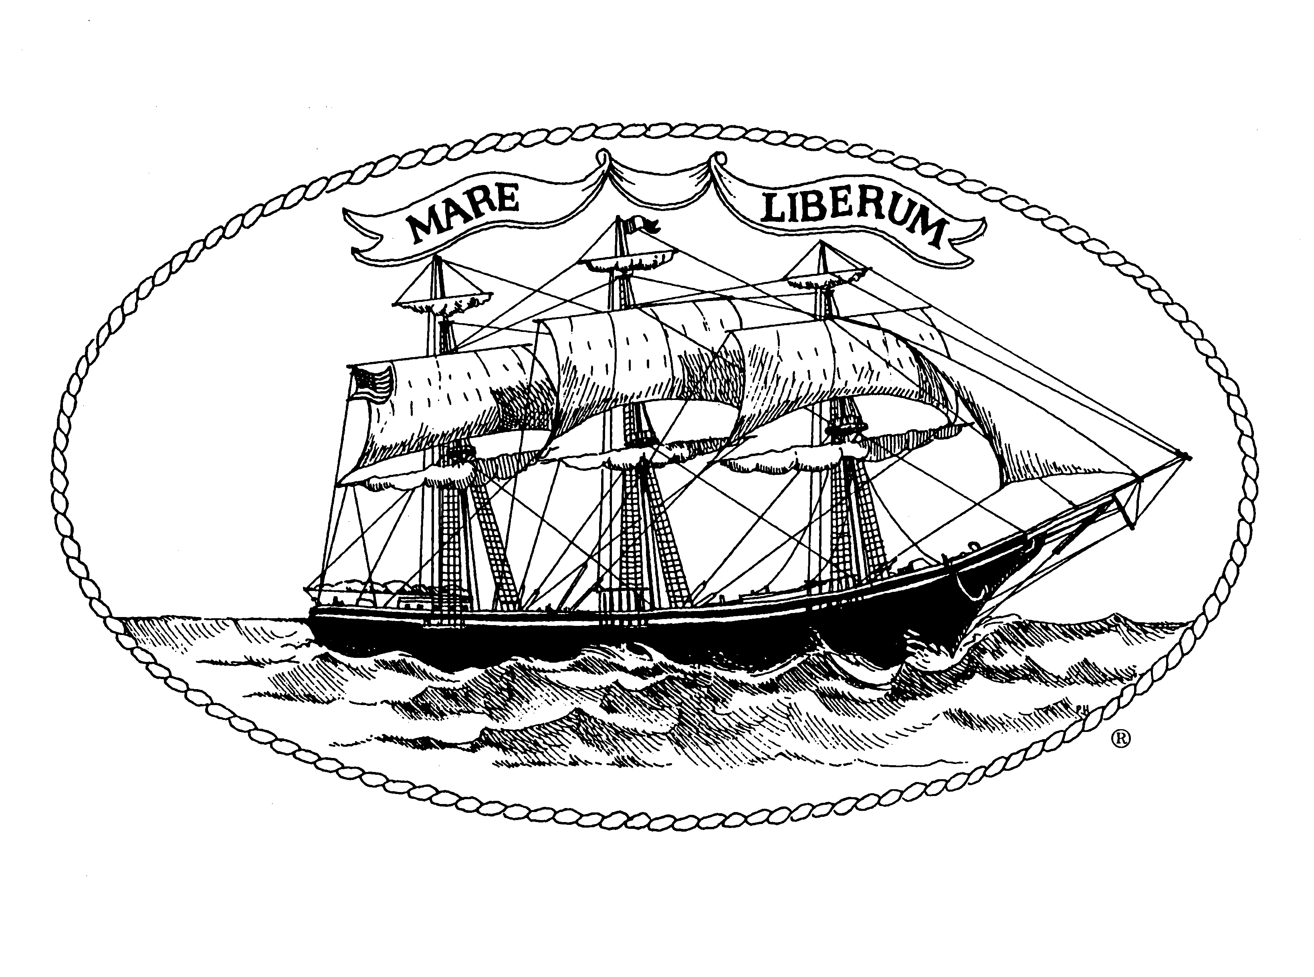
City of New London

Community Development Block Grant Program
Fifty First Program Year
July 1, 2025 – June 30, 2026

Public Services Application
Due Date: January 9, 2025 by 4:00 pm

Note: Also Review “Notice of Funding Availability”

Part I: General Information

Agency/Department:

Address:

Exec. Dir./Dept. Head:

Project Director/
Contact Name & Title:

E-mail Address of Contact
Person (Required) ________________________________________________________________

Telephone:

Proposed Program Name:

Person Authorized to Sign
On Behalf of Agency:

Person Authorized to
Request Funds:

CDBG Request & Award Amounts: Request Award

Upcoming Fiscal Year
(July 1, 2025 - June 30, 2026) $

If Current Fiscal Year Award
(July 1, 2024 - June 30, 2025) $ $

I/we certify that the information contained herein and attached as exhibits hereto is, to the best of our knowledge and belief, true, correct and complete and that the City of New London can rely upon these statements in determining whether to fund this project. We certify that the Agency Board of Directors has approved this application.
□ The NOFA contains guidelines for applicants with updates each year. Please verify you have read the NOFA.

Exec. Dir./Dept. Head Date Chair, Board of Directors Date
Part II: Program/Agency Information

- Proposed Program Summary

1. Clearly state exactly what the requested CDBG funds are to be used for

2. Need/problem to be addressed

3. Population to be served

4. Description of activity/service

5. Goals/objectives of the activity/service

6. Method of approach to achieve the outcomes desired

- Program Details
- Client information
  - Estimate the number of clients to be served.
  - Defining characteristics such as age, gender, ethnicity, and income level.

- Activity/program detail
  - Who will carry out the activities?

  - Where will the activities be carried out?
    - Describe the site where the program will be implemented.
    - How will clients get to the facility?
    - What efforts will your agency and partners make to promote your program and reach isolated individuals?
    - Describe how the facility complies with Americans with Disabilities Act (ADA) requirements regarding accessibility.

  - Implementation schedule
    - Explain the period over which the activities will be carried out.
    - The frequency with which services will be delivered

  - Coordination: how will you coordinate your services with other community agencies and leverage resources?

- Reduced funding
  - If you do not receive the amount of funds requested, how do you propose to administer and/or complete the program in the manner presented?

  - What items would you reduce or eliminate from your budget?

  - Describe how this will impact the number of persons to be served.
- Addressing a CDBG National Objective:

Does your program:

Address the needs of low- and/or moderate-income residents?

OR

Eliminate Slums or Blight?

D. Program Beneficiary Statistics: Note to current CDBG subrecipients: this information can be obtained from quarterly reports.

Individuals Served | July 2023 –  June 2024 | Anticipated  July 2024 –  June 2025 | Anticipated  July 2025 –  June 2026
Total # of unduplicated individuals served by your program.
# of New London residents
# of residents from other towns

E. Agency/City Department Information (City departments: write this section as if you are submitting the application to an entity that does not know how your department/program operates. This is necessary to meet the requirements of the program.)

- Background/Program Experience: Include the length of time the agency has been in operation, the date of incorporation, the purpose of the agency, and the type of corporation. Describe the type of services provided, the agency’s capabilities, the number and characteristics of clients served, and license to operate (if appropriate).

- Personnel/Staff Capacity: Briefly describe the agency’s existing staff positions and qualifications, its capacity to carry out this activity, and state whether the agency has a personnel policy manual with an affirmative action plan and grievance procedure.

- Monitoring: Briefly describe how you will monitor progress in implementing the program. Attach copies of data collection tools that will be used to verify achievement of program goals and objectives. Describe who will be responsible for monitoring progress.

Part III: Financial Information
  - Financial Capacity: Describe the agency’s/department’s fiscal management, including financial reporting, record keeping, accounting systems, and payment procedures. City Departments are required to respond to this section.

  - Sources of Revenue: Please complete the budget form below demonstrating your agency/department estimated revenue by source and the proposed program sources of funding. City Departments are required to respond to this section.

Revenue Source of Your Agency/City Department | Estimated Agency  Budget | Proposed Program Budget
Program Fees
United Way
Foundations
Donations

CDBG (requested amount)
NL General Fund
State Government
Federal Government
Other Revenue (specify in lines below)
TOTAL

- TOTAL PROPOSED PROGRAM BUDGET IS WHAT PERCENTAGE OF THE
TOTAL AGENCY BUDGET? %

- CDBG AMOUNT REQUESTED IS WHAT PERCENTAGE OF THE TOTAL
PROGRAM BUDGET? %

3. CDBG AMOUNT REQUESTED IS WHAT PERCENTAGE OF TOTAL AGENCY BUDGET? %

  - Proposed Program Detailed Budget: Please complete the budget form below breaking down the proposed program costs by category (exactly what you want to use CDBG funds for). Please consult with Community Development representative, if there are questions on eligible expenses.

Source of Funds:
CDBG
(Requested amt.)
Salaries/wages:
Payroll (List each person’s payroll involved with the project.)
Overtime
Salaries Subtotal
Fringe Benefits ( % of wages)
Purchased Services:
Engineering/Architect
Consulting
Legal Services
Professional Services
Advertising
Printing
Dues & Subscriptions
Travel & Transportation
Rentals & Leases
Training
Other Operating Services
Postage
Courier
Telephone
Maintenance & Repairs Services
Purchased Services Subtotal
Supplies & Materials:
Consumables (non-food items unless this is a nutrition program)
Computer Equipment
Supplies Subtotal
Capital Improvements:
Capital Improvements other than Buildings
Capital Subtotal
Grand Total: (requested amt.)

Part IV: Supplemental Information
Exhibits Not Required for Applications Submitted by
City of New London Departments
All agencies must submit the following documentation with their application whether or not you have previously received CDBG funds through the City of New London.

Please provide only one copy of these materials.

Exhibit 1 Financial Statement/Audit
Include a copy of your organization’s most recent audit report or a financial statement. If your organization is not required to complete an audit report based on the amount of Federal funding expended during the previous year, please submit a detailed financial statement.

Non-Federal entities that expend $500,000 or more in a year in Federal awards shall have a single or program-specific audit conducted for that year in accordance with the provisions of OMB Circular A-133 – Audits of Institutions of Higher Education and Non-Profit Institutions.

Exhibit 2 Insurance/Bond/Worker’s Compensation
- State whether or not the agency has liability insurance coverage, in what amount and with what insuring agency.
- State whether or not the agency pays all payroll taxes and worker’s compensation as required by Federal and State Law.
- State whether or not the agency has fidelity bond coverage for principal staff who handle the agency’s accounts, in what amount and with what insuring agency.
- Provide a copy of a current insurance certificate, not a policy.

Exhibit 3 Non-Profit Determination
Non-profit organizations must submit tax-exemption determination letters from the Federal Internal Revenue Service.

Exhibit 4 List of Board of Directors
A list of the current board of directors or other governing body of the agency must be submitted. The list must include the name, telephone number, address, occupation or affiliation of each member; and must identify the principal officers of the governing body.

Exhibit 5 Organizational Chart
An organizational chart must be provided which describes the agency's administrative framework and staff positions. This chart must indicate where the proposed project will fit into the organizational structure and identify any staff positions of shared responsibility.

Exhibit 6 List Chief Program Administrator and Chief Financial Officer and credentials indicating necessary experience (or include resume).

Exhibit 7 Conflict of Interest Disclosure
Appropriate HUD regulation is attached and must be read. Disclosure form is attached and must be completed and signed.

Proposals are due by Thursday, January 9, 2025 by 4:00 p.m.

Applications submitted after the deadline will not be considered.

