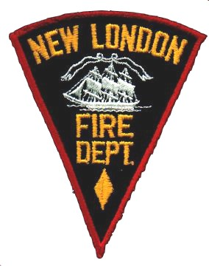 New London Fire Department 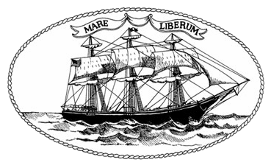
289 Bank Street
New London Connecticut

For Immediate Release

Press Release: Home Heating Safety
Did you know that one half of all home heating fires occur between December and February each year! One in every seven home fires involves heating equipment! Each year fire departments respond to an average of 48,000 of these types of fires that result in an average of 500 deaths and 1,300 injuries. Please take a moment to review these very simple steps for safe operation of portable heaters:

- Keep anything that can burn 3 feet away from portable heaters (or any heating equipment -i.e., fire place, wood stove and furnace)
- Turn off the portable heater when you leave the room or when you go to bed.
- Make sure your heater has been tested by a recognized laboratory
- Make sure your heater has automatic shut off so if it tips over it shuts off.
- Ensure the heater is located on a solid flat surface.
- Plug the portable heater directly into the wall electrical receptacle (do not use an extension cord)
Should you have a fire in your home or apartment when you leave the apartment close your door. This may help contain the fire.

Follow this link https://youtu.be/nZAhqjsT1vI for more winter safety information from the US Fire Administration. Please take the time to ensure you have working smoke alarms in your homes. They should be located at a minimum outside and in the vicinity of the bedrooms and at least one on every level of the home. Should you have any questions please reach out to the Fire Marshal’s Office at (860) 447-5294

Thank You,

Vernon Skau, Fire Marshal
New London Fire Department

